**Read Me First**

**The Encirclement of Nancy (1944)**

**Virtual Staff Ride**

1. **INTRODUCTION**
   1. **Overview:** This staff ride examines the operations of the US Third Army in the encirclement of Nancy during the 1944 Lorraine Campaign. The field study first overviews the US Army’s breakout from the Normandy beachhead and the subsequent 500-mile pursuit of the German Army to the Moselle River (August 1944). The field study then examines the US Third Army’s various efforts to cross the Moselle River in September 1944. The field study focuses primarily on the US XII Corps with a detailed examination of the 80th and 35th Infantry Divisions’ efforts to secure the bridgeheads over the Moselle. Next, the field study examines the 4th Armored Division’s breakout from the bridgehead and its 35-mile attack into to encircle the city of Nancy. Lastly, the study examines the subsequent German counterattacks which became the Battle of Arracourt. The full staff ride takes 6 to 8 hours to execute. We recommend the field study be executed over two-days (4 hours each day).
   2. **Note to Instructors:** This staff ride is large and complex involving one US Field Army and a German Army Group. The field study examines multiple Corps and the instructors and VSR operators must thoroughly study all the preliminary and field phase material to execute this staff ride well. There are five databases maintained in VBS3 for the VSR. Navigation on the virtual terrain requires a significant rehearsal effort prior to the execution.
   3. **Learning Objective:** The primary learning objective is to discuss the enduring insights of war as a human endeavor in the study of a large-scale combat operation (LSCO) during World War II. Even though this is a LSCO study, significant portions of the field study focus on the actions of brigade and battalion-size organizations, and the staff ride can be tailored to concentrate on issues important to company, and battalion leadership. The ride itself offers insights into the following aspects of warfare, though additional themes may be developed based on unit training objectives: leadership and mission command, operational reach (sustainment constraints), wet gap crossings, offensive and defensive operations, air-ground operations, terrain analysis, and other warfighting functions.
2. **HOW TO USE THE VIRTUAL STAFF RIDE**
   1. **Definitions:**

(1) Virtual Terrain: The “3D” terrain projected to the front of the classroom. This is the primary tool used to bring the battlefield into the classroom.

(2) Virtual View: A viewpoint on the “ground” in the virtual terrain used to stop and discuss the battle. The “virtual view” is a title found in both the “instructor notes” and the “screen movements” to synchronize those two documents (see below).

1. **Virtual Staff Ride Format.**

**(1) Instructor Notes/Walk Book:** In the field study, the instructor uses the instructor notes, or walk book, as a lesson plan for the staff ride. This guide contains a description of the terrain, the significant events, and analysis questions, which are broken up by stand. A staff ride walk book follows an *Orientation*, *Description*, *Analysis* format:

(a) Orientation: identifies all the relevant terrain to the participant.

(b) Description: contains the events that pertain to that stand (normally in chronological order).

(c) Analysis: contains the questions asked to guide the participants toward the insights that can be gained from the staff ride.

**(2) The *virtual orientation*** is further broken into two parts:

(a) Orientation to the Situation (using PowerPoint Slides at the beginning of the stand) which presents the background events/information needed to focus the participants on the stand.

(b) Orientation to the Terrain(using the virtual terrain) which presents all the relevant terrain and should be tied to the maps that are provided. The *terrain orientation* occurs when the virtual terrain is first presented and can also be executed anywhere the instructor feels he/she needs to keep the participant oriented.

**(3) Visual Aids:** Another element to the walk book is the use of visual aids for each stand. These are normally maps or important pictures/diagrams that are brought to the battlefield on large boards and are used to guide or enhance the discussion. The virtual staff ride uses PowerPoint presentations, and these will be referred to in the instructor notes as “Visuals”. These PowerPoint presentations may be animated to present the events in a chronological order and to assist both the instructor and participants in understanding movement/placement of units, vehicles, and personnel.

**c. Classroom Setup:** With the need to show the participants the virtual terrain and the visuals simultaneously, the required classroom setup should have two screen views. Try to have two computer/projector combinations, with the virtual terrain projected in the center, and the visuals projected off to the right or left. While it is possible to switch back and forth between views, it is encouraged to use the dual screen method, for a clear understanding of the events. Also, it is not advisable to have a class size larger than 30 participants. The smaller class size allows for increased participation and better view of the virtual terrain for all the participants.

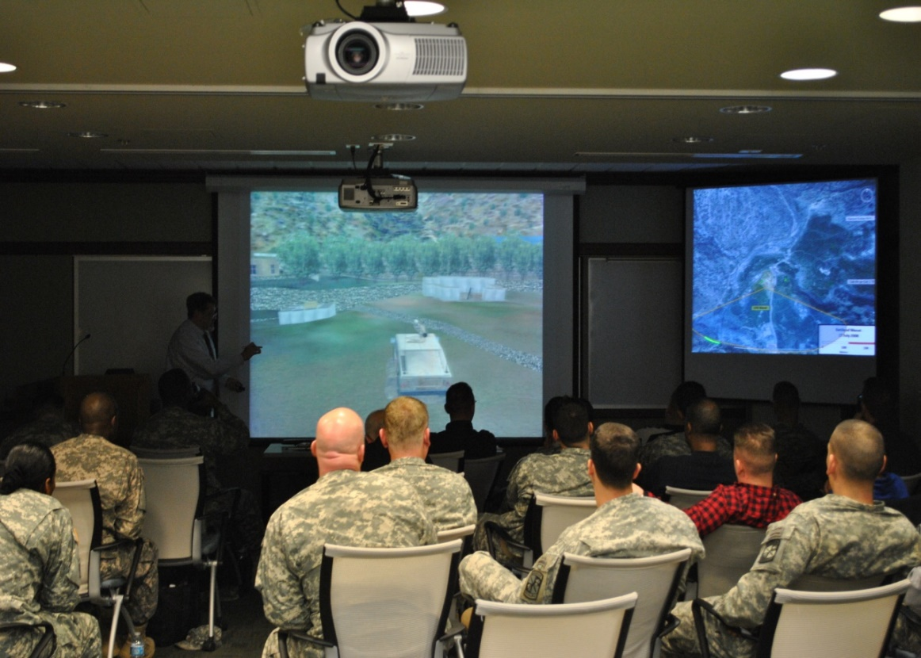

**d. Time Requirements:** The VSR is executed as two modules. Each module is meant to be completed in three to four hours, though with adjustments they can be completed in less, but at the cost of reduced content and discussion.

1. **THE VIRTUAL STAFF RIDE CONTENTS.** Ensure you download the following files from the Staff Ride Team page on the Army University Press website:

**a. Instructor Notes.** The instructor notes are in two volumes. Volume I is “Crossing the Moselle River,” and Volume II is “The Breakout and the Battle of Arracourt.” These volumes contain the notes required for the instructor and the “flight” instructions for the virtual terrain operator. We recommend both instructor and VBS operator should have a copy of both volumes.

**b. The Visuals.** PowerPoint slides (visuals) used to convey key information to the participants. The visuals are in two parts. Part 1 is “Crossing the Moselle River,” and Part 2 is “The Breakout and the Battle of Arracourt.” Some visuals are animated and cued by the instructor; others are stand-alone and have no animation.

**c. The Virtual Terrain.** There are five databases maintained in VBS3 for the VSR. Each of these databases is referred to as a VSR Box in the Instructor Notes. Because of the significant load time for some of the data bases, if possible, we recommend the data base be installed on two computers for the conduct of the field study.

|  |  |
| --- | --- |
| **COMPUTER 1** | **COMPUTER 2** |
| **Stand 1**  **Commercy Box** | **Stand 2 & 3**  **Pont-a-Mousson Box** |
| **Stand 4 & 5**  **Southern Bridgehead Box** | **Stand 6**  **Pont-a-Mousson Box** |
| **Stand 7 & 8**  **Breakout Box** | **Stand 9, 10, 11, & 12A**  **Arracourt Box** |
| **Stand 12B**  **Breakout Box (Gremecy Forest)** |  |